Adsorption of Pb²⁺ from Wastewater by Polymerizable Surfactant-Modified Oyster Shells: A Fixed Bed Column Study

Meng, K*¹⁾, Asnachinda, E²⁾
¹⁾ The University of Cambodia, Phnom Penh, Cambodia
²⁾Burapha University, Chonburi Province, Thailand
* Corresponding author’s email address: kro.meng@yahoo.com

Keywords: Adsorption; Fixed bed column; Polymerizable Surfactant-Modified-Oyster Shell.

Introduction
Industrial effluent is the main source of heavy metal pollution. Heavy metals are serious and complicated problems resulting from environmental pollution; heavy metals such as cadmium, lead, mercury, copper, chromium, iron, zinc and nickel are often found in discharged industrial wastewater (Kargi et al., 2006; Lodeiro et al., 2006; Amarasinghe et al., 2007). Without appropriate treatment, water containing such toxic heavy metals has serious consequences for human health and aquatic life (Suzuki et al., 2005; Lodeiro et al., 2006; Uçurum, 2009). Heavy metals are non-biodegradable and excessively discharged into the environment due to rapid industrialization which is of major global concern. Lead is the most common toxic heavy metal. The annual consumption of lead is about 3 million tons, of which 40% is used in electrical accumulator and batteries, 20% in gasoline, 12% in building construction, 6% in cable coatings, 5% in ammunition and 17% in other usages (Lawrence, 2009). Heavy metals are dangerous even at lower concentrations from 0.001 to 0.1 mg/L (Yahaya, 2008; Lawrence, 2009). Exposure to high lead concentrations cause learning disabilities (Sarı et al., 2007) and negatively affects reproductive, neurological and renal functions (Malakootian et al., 2009; Nguyen, et al., 2013; Saravanan et al., 2012).
The biosorption process for the removal of heavy metals from industrial effluent is a novel alternative technology for industrial wastewater treatment. This process is more desirable than chemical precipitation, ions exchange, and other chemical methods for the removal of toxic heavy metals because of the lower cost and high uptake capacity (Kargi et al., 2006). Oyster shells contain large amounts of organic compounds and macromolecules including chitins/chitosans which enable the removal of heavy metals due to the presence of hydroxide and amino groups (Liu et al., 2009; Wan Ngah et al., 2011). Moreover, there are many applications using surfactant-modified adsorbents that have received much attention for their ability to remove many kind of contaminants such as crystal violet dye (Adak et al., 2006) and heavy metals (Su et al., 2011; Choi et al., 2009). The objective of the study is to set up an application study by apply system in a continuous fixed bed column and investigate the effect of the flow rate of lead concentration in polymerization.

Material and Methods
Packed bed lead adsorption studies were conducted to evaluate dynamic behaviour for lead removal onto oyster shells. The oyster shells with the desired heights were packed in an acrylic column (2 cm internal diameter and 10 cm height) between two supporting layer of glass wool. A layer of glass beads was placed at the top to provide a uniform inlet flow. The experiments were performed by pumping solution in the up-flow mode using a peristaltic pump at room temperature (28±2ºC). The weight of the oyster shells used in the column was 1.25 g. The soft silicone tube (6 mm inner and 7.5 mm outer diameter) was introduced to connect the peristaltic pump with the acrylic packed bed column. An experiment was carried out to study the effects of the flow rate 1 and 3 ml/min through the bed using a peristaltic pump. The lead concentration was 100 mg/L.

Results and Conclusions
The hydraulic loading is an important parameter as it determines the contact time of the adsorbate with the adsorbent in a packed bed column. The breakthrough curves at two different flow rates, 1 and 3 ml/min, were investigated. Figure 1.1 was plotted between the C/C₀ versus time on a breakthrough curve. The results illustrated that under the higher flow rate 3 ml/min, a lead breakthrough curve was noted immediately.
The breakthrough time was 220 and 15 min for 1 and 3 ml/min of flow rates, respectively. A short breakthrough time at a high flow rate of lead solution was reported (Long et al., 2014; Li et al., 2009). The column with the flow rate of 3ml/min reached the exhaustion earlier than 1ml/min which the saturation times were 55 and 260 min for 3 and 1 ml/min, respectively. The result indicated that the best performance was at lower flow rate (1 ml/min). The lead adsorption capacity was increased when the flow rate is low due to the driving force for binding site of lead solution with oyster shells.
The typical breakthrough curve suggested that a lower flow rate is necessary to ensure that an appropriate contact time is provided for the adsorption process to occur in a fixed bed column. In the study, the percentage of lead removal decreased with increasing the flow rate; this might be less residence time of the solution through the column at high flow rate. The result of this study was in agreement with the previous work which used mollusks to adsorb Cd from aqueous solution (Li et al., 2009). In total, the result verified that the polymerizable surfactant-modified oyster shells are successful in removing the lead from the wastewater. For the column tests, breakthrough figures were employed to determine the time in which the metals breakthrough and exhaustion after running the column tests.
Figure 1.2 shows the relationship between C/C₀ and pore volume for polymerization system. A flow rate of 1ml/min generally allows more adsorption capacity than 3ml/min for lead removal in a fixed bed column. The lead exhaustion increased with increasing the pore volume due to greater metal number of binding site and higher contact time for lead removal to take place within the column. The column was operated with a flow rate 3 ml/min typically exhausted sooner than the flow rate of 1ml/min. This is likely due to the high rate of lead ions passing through the column and the limited number of opportunities for an active binding site to be contacted with the metal solution (Liu et al., 2009).
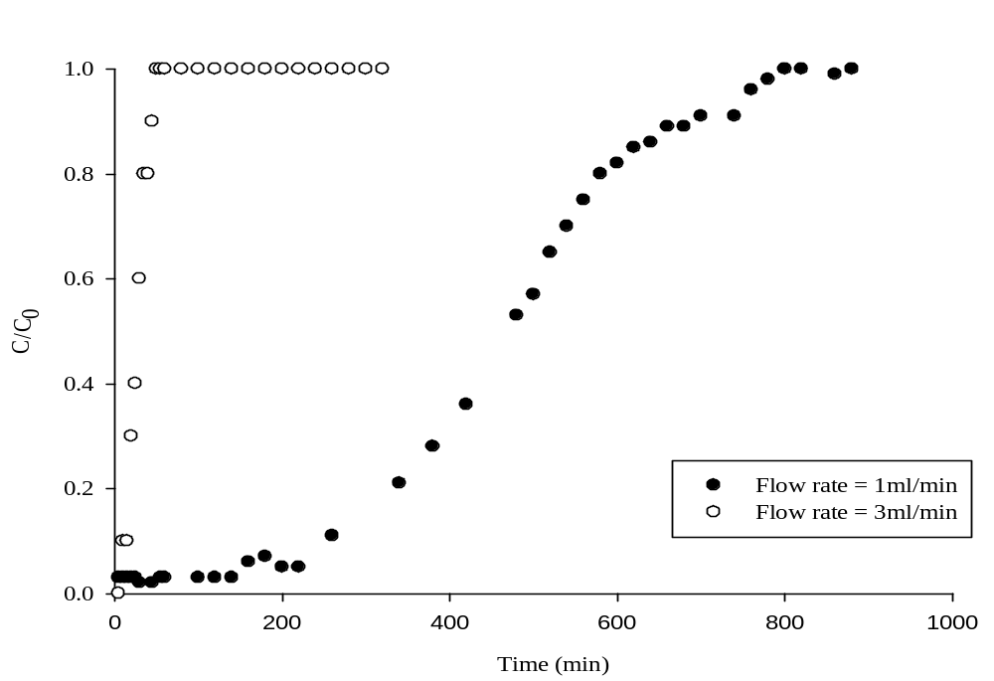
Figure 1.1 Flow rate of 1 and 3 ml/min (initial lead concentration of
100 mg/L, bed height: 4 cm at operation pH 6-7 for polymerization
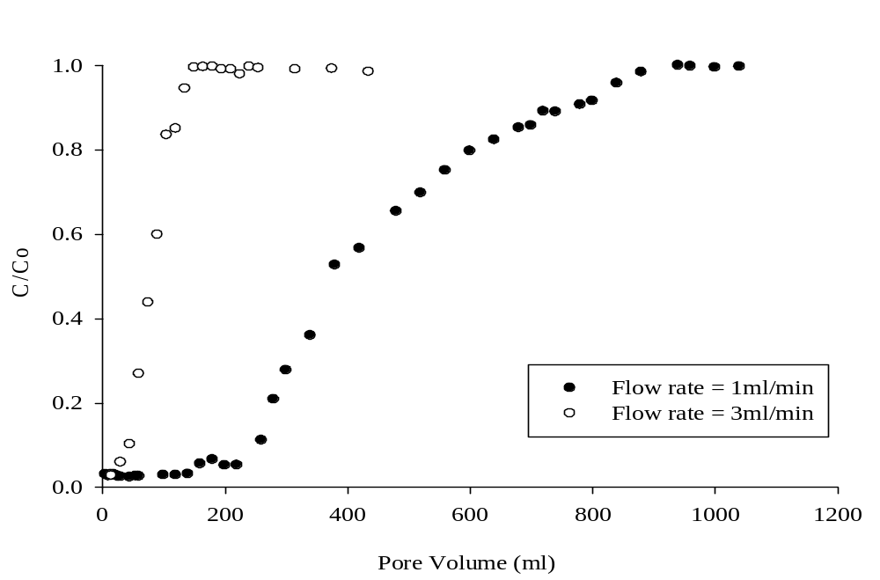
Figure 1.2 Flow rate 1 and 3 ml/min, initial lead concentration of 100 mg/L,
Bed height: 4 cm at operation pH 6-7 for polymerization

References
Adak, A., Bandyopadhyay, M., and Pal, A. (2006), Fixed bed column study for the removal of crystal violet (C. I. Basic Violet 3) dye from aquatic environment by surfactant-modified alumina. Dyes and Pigments, 69(3), 245–251.
Amarasinghe, B. M. W. P. K. and Williams, R. A. (2007), Tea waste as a low cost adsorbent for the removal of Cu and Pb from wastewater. Chemical Engineering Journal, 132(1–3), 299–309.
Kargi, F., and Cikla, S. (2006), Biosorption of zinc(II) ions onto powdered waste sludge (PWS): Kinetics and isotherms. Enzyme and Microbial Technology, 38(5), 705–710.
Lawrence K.Wang, J. P.-T. (2009), Heavy metals in the environment. United Stated of American.
Li, C., and Champagne, P. (2009), Fixed-bed column study for the removal of cadmium (II) and nickel (II) ions from aqueous solutions using peat and mollusk shells. Journal of Hazardous Materials, 171, 872–878.
Liu, Y., Sun, C., Xu, J., and Li, Y. (2009), The use of raw and acid-pretreated bivalve mollusk shells to remove metals from aqueous solutions. Journal of Hazardous Materials, 168(1), 156–162.
Lodeiro, P., Barriada, J. L., Herrero, R., and Sastre de Vicente, M. E. (2006), The marine macroalga Cystoseira baccata as biosorbent for cadmium(II) and lead(II) removal: Kinetic and equilibrium studies. Environmental Pollution, 142(2), 264–273.
Long, Y., Lei, D., Ni, J., Ren, Z., Chen, C., and Xu, H. (2014). Packed bed column studies on lead (II) removal from industrial wastewater by modified Agaricus bisporus. Bioresource Technology, 152, 457–463.
Malakootian, M., Nouri, J., & Hossaini, H. (2009), Removal of heavy metals from paint industry's wastewater using Leca as an available adsorbent. International Journal Environ. Sci. Tech, 6(2), 183-190.
Nguyen, T. A. H., Ngo, H. H., Guo, W. S., Zhang, J., Liang, S., Yue, Q. Y., Nguyen, T. V. (2013), Applicability of agricultural waste and byproducts for adsorptive removal of heavy metals from wastewater. Bioresource Technology.
Sarı, A., Tuzen, M., Uluözlü, Ö. D., and Soylak, M. (2007). Biosorption of Pb(II) and Ni(II) from aqueous solution by lichen (Cladonia furcata) biomass. Biochemical Engineering Journal, 37(2), 151–158.
Saravanan, Uvaraja, Nishanth, & Krishnan, S. (2012), Column Study on the Removal of metals from industrial effluent using the biomass Sargassum sp. International Journal of Applied Research in Mechanical Engineering (IJARME), Volume-2.
Suzuki, Y., Kametani, T. and Maruyama, T. (2005), Removal of heavy metals from aqueous solution by nonliving Ulva seaweed as biosorbent. Water Research, 39(9), 1803–1808.
Su, J., Huang, H.-G., Jin, X.-Y., Lu, X.-Q., and Chen, Z.-L. (2011), Synthesis, characterization and kinetic of a surfactant-modified bentonite used to remove As(III) and As(V) from aqueous solution. Journal of Hazardous Materials, 185(1), 63–70.
Uçurum, M. (2009), A study of removal of Pb heavy metal ions from aqueous solution using lignite and a new cheap adsorbent (lignite washing plant tailings). Fuel, 88(8), 1460–1465.
Wan Ngah, W. S., Teong, L. C., and Hanafiah, M. A. K. M. (2011), Adsorption of dyes and heavy metal ions by chitosan composites: A review. Carbohydrate Polymers, 83(4), 1446–1456.
Yahaya, Y. A. (2008), Biosorption of Selected Heavy Metals by Free and Immobilized Pycnoporus Sanguineus: Batch and Column Studies. Master's thesis, Department of Chemical Engineering .

